**NAME …………………………………………………SIGN……………….**



**END OF TERM I EXAMINATION 2024**

**SENIOR THREE BIOLOGY**

**TIME 2 HOURS**

**Instructions**

***Attempt all questions in this paper***

***Question 1***

At the end of 2022, Uganda reported that hepatitis had killed 1250 people, Ebola-1590 and 5200 due to AIDS. The report explained the cause of each disease and its effect on different human body organs and systems. Extremely high infection rates of cassava crops by leaf mosaic disease was also reported. For each disease, Ugandans were sensitized on symptoms and mode of transmission but did not include prevention measures. Write the key information on each disease based on the report and suggest possible measures of prevention. ***(20 scores)***

……………………………………………………………………………………………………..

……………………………………………………………………………………………………..

……………………………………………………………………………………………………..

……………………………………………………………………………………………………..

……………………………………………………………………………………………………..

……………………………………………………………………………………………………..

……………………………………………………………………………………………………..

……………………………………………………………………………………………………..

……………………………………………………………………………………………………..

……………………………………………………………………………………………………..

……………………………………………………………………………………………………..

……………………………………………………………………………………………………..

……………………………………………………………………………………………………..

……………………………………………………………………………………………………..

……………………………………………………………………………………………………..

……………………………………………………………………………………………………..

……………………………………………………………………………………………………..

……………………………………………………………………………………………………..

……………………………………………………………………………………………………..

……………………………………………………………………………………………………..

……………………………………………………………………………………………………..

……………………………………………………………………………………………………..

***Question 2***

In the body, different processes need energy to run smoothly, these directly or indirectly require oxygen. As different organisms take up gases easily from the environment through their body surfaces, man is unique that has developed a respiratory system. This system has enabled human beings to take in air from the environment and with its subsequent carriage to body cells.

1. Explain why man developed the respiratory system. ***(05 scores)***
2. State how gases can be carried to body cells from the environment. ***(15 scores)***

……………………………………………………………………………………………………..

……………………………………………………………………………………………………..

……………………………………………………………………………………………………..

……………………………………………………………………………………………………..

……………………………………………………………………………………………………..

……………………………………………………………………………………………………..

……………………………………………………………………………………………………..

……………………………………………………………………………………………………..

……………………………………………………………………………………………………..

……………………………………………………………………………………………………..

……………………………………………………………………………………………………..

……………………………………………………………………………………………………..

……………………………………………………………………………………………………..

……………………………………………………………………………………………………..

……………………………………………………………………………………………………..

……………………………………………………………………………………………………..

……………………………………………………………………………………………………..

……………………………………………………………………………………………………..

……………………………………………………………………………………………………..

……………………………………………………………………………………………………..

……………………………………………………………………………………………………..

……………………………………………………………………………………………………..

……………………………………………………………………………………………………..

……………………………………………………………………………………………………..

……………………………………………………………………………………………………..

……………………………………………………………………………………………………..

……………………………………………………………………………………………………..

……………………………………………………………………………………………………..

……………………………………………………………………………………………………..

……………………………………………………………………………………………………..

……………………………………………………………………………………………………..

……………………………………………………………………………………………………..

***Question 3***

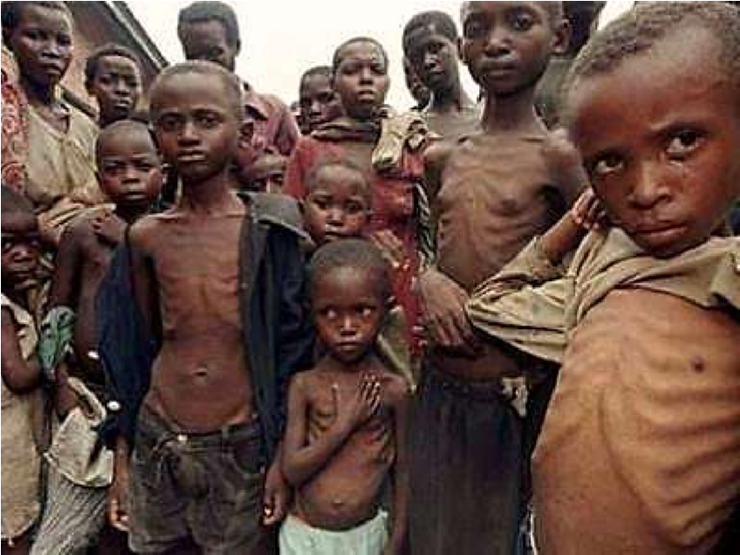Some slum areas have children that look weak, pale and were quite inactive as shown below. They rarely play or run around like other children of their age because on addition to lack of energy, some of the children have crippled bodies and so big. The school through the biology teacher and school doctor, intend to organize a medical camp for the slum children. The medical camp is aimed at discussing the cause of the above cases in children, the likely effects in case the challenges were not addressed and possible solutions to the above cases in children. The school is to purchase some food materials for the children as well. The biology teacher approaches you to prepare a speech to the slum children.

1. As an S.3 student, use the knowledge of nutrient compound advise the school on what

they should purchase for the children. ***(10 scores)***

1. Write a speech that shall help the slum children to restore their normal life. ***(10 scores)***

……………………………………………………………………………………………………..

……………………………………………………………………………………………………..

……………………………………………………………………………………………………..

……………………………………………………………………………………………………..

……………………………………………………………………………………………………..

……………………………………………………………………………………………………..

……………………………………………………………………………………………………..

……………………………………………………………………………………………………..

……………………………………………………………………………………………………..

……………………………………………………………………………………………………..

……………………………………………………………………………………………………..

……………………………………………………………………………………………………..

……………………………………………………………………………………………………..

……………………………………………………………………………………………………..

……………………………………………………………………………………………………..

……………………………………………………………………………………………………..

…………………………………………………………………………………………………….. ……………………………………………………………………………………………………..

……………………………………………………………………………………………………..

……………………………………………………………………………………………………..

……………………………………………………………………………………………………..

……………………………………………………………………………………………………..

***Question 4***

Two students of S.3 were touring their school banana plantation with much weeds. Each of them uprooted these plants and argued as to whether they are either monocots or dicots.

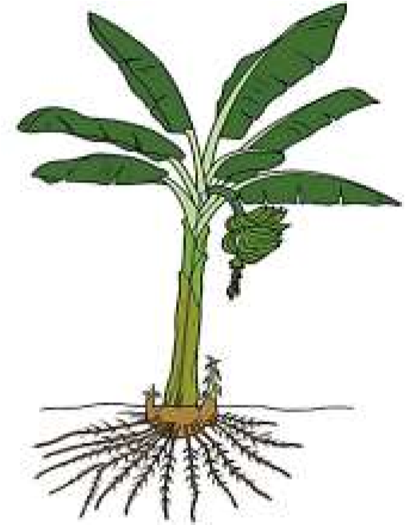 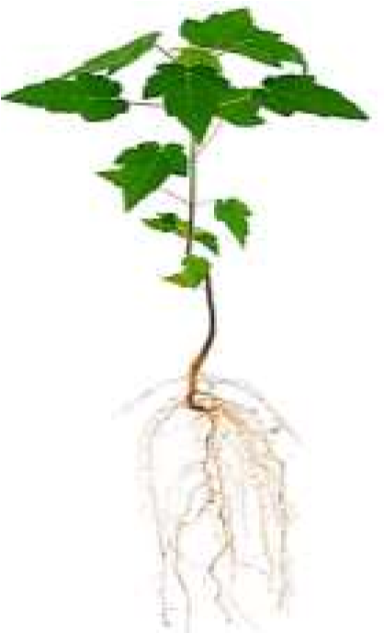

Banana plant A weed

1. As a friend to both, how would you help them settle their argument? *(****07 scores****)*
2. Explain to them how the different plant organs on both plants are modified to carry out

the different functions. ***(13 scores)***

……………………………………………………………………………………………………..

……………………………………………………………………………………………………..

……………………………………………………………………………………………………..

……………………………………………………………………………………………………..

……………………………………………………………………………………………………..

……………………………………………………………………………………………………..

……………………………………………………………………………………………………..

……………………………………………………………………………………………………..

……………………………………………………………………………………………………..

……………………………………………………………………………………………………..

……………………………………………………………………………………………………..

……………………………………………………………………………………………………..

……………………………………………………………………………………………………..

……………………………………………………………………………………………………..

……………………………………………………………………………………………………..

……………………………………………………………………………………………………..

……………………………………………………………………………………………………..

……………………………………………………………………………………………………..

……………………………………………………………………………………………………..

……………………………………………………………………………………………………..

***END***